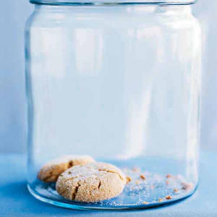

Cookie Storage Strategies

Simple tips to keep your cookies crispy or chewy

General tips
• Always store baked cookies only after they've cooled completely. If you store them while they're still warm, condensation will make them soggy.
• Don't combine different cookie types in the same storage container, as softer cookies will leach moisture that may cause crisp cookies to soften.
• Store cooled cookies in airtight containers to prevent humidity from affecting their texture.
• Store soft cookies with an apple wedge to help retain moisture. Discard it before serving.
• If crisp cookies soften, recrisp them by baking at 300° for five minutes, and cool completely on a wire rack.
• You can refrigerate or freeze most cookie dough, so you can bake a batch at a moment's notice. You do not need to thaw frozen cookie dough; just bake an additional minute or two. You can also freeze baked cookies for a few months; thaw at room temperature for 10 to 15 minutes.
Special considerations
Drop cookies (except meringues): You can freeze tablespoon-sized portions of dough in a single layer on a baking sheet, and then transfer to a heavy-duty zip-top plastic bag.
Rolled cookies: Store decorated cookies between layers of wax paper.
Sliced/icebox cookies: Freeze dough logs; slice just before baking. If too firm, thaw at room temperature 10 to 15 minutes.
Hand-shaped cookies: Freeze dough balls in a single layer on a baking sheet, then transfer to a heavy-duty zip-top plastic bag. Thaw at room temperature for 10 to 15 minutes, then shape.
Twice-baked cookies: Because these cookies are dry and crisp, they store well at room temperature for an extended time.
Bar cookies: Store cookies in the pan in which they bake; cover with plastic wrap or foil.
Shelf life
• Dough for rolled, sliced/icebox, hand-shaped, and drop cookies (except meringues) will keep for two to three days in the refrigerator or three months in the freezer. Twice-baked and bar cookie doughs should be baked immediately.
• After baking, all cookie varieties will keep for three months in the freezer. At room temperature, rolled, sliced/icebox, hand-shaped, and drop cookies (except meringues) will keep for three to five days . Twice-baked cookies will keep for two weeks, and bar cookies will keep for 3 to 4 days. Baked cookies should not be refrigerated.

